['id', 'week', 'checkout_price', 'base_price', 'emailer_for_promotion', 'homepage_featured', 'num_orders', 'category', 'cuisine', 'city_code', 'region_code', 'center_type', 'op_area']

In [27]:

cols **=** cols[:2] **+** cols[9:] **+** cols[7:9] **+** cols[2:7]

print(cols)

['id', 'week', 'city_code', 'region_code', 'center_type', 'op_area', 'category', 'cuisine', 'checkout_price', 'base_price', 'emailer_for_promotion', 'homepage_featured', 'num_orders']

In [28]:

trainfinal **=** trainfinal[cols]

trainfinal**.**dtypes

Out[28]:

id int64

week int64

city_code int64

region_code int64

center_type object

op_area float64

category object

cuisine object

checkout_price float64

base_price float64

emailer_for_promotion int64

homepage_featured int64

num_orders int64

dtype: object

In [30]:

**from** sklearn.preprocessing **import** LabelEncoder

In [32]:

lb1 **=** LabelEncoder()

trainfinal['center_type'] **=** lb1**.**fit_transform(trainfinal['center_type'])

lb2 **=** LabelEncoder()

trainfinal['category'] **=** lb1**.**fit_transform(trainfinal['category'])

lb3 **=** LabelEncoder()

trainfinal['cuisine'] **=** lb1**.**fit_transform(trainfinal['cuisine'])

In [33]:

trainfinal**.**head()

Out[33]:

|  | **id** | **week** | **city_code** | **region_code** | **center_type** | **op_area** | **category** | **cuisine** | **checkout_price** | **base_price** | **emailer_for_promotion** | **homepage_featured** | **num_orders** |
| --- | --- | --- | --- | --- | --- | --- | --- | --- | --- | --- | --- | --- | --- |
| **0** | 1379560 | 1 | 647 | 56 | 2 | 2.0 | 0 | 3 | 136.83 | 152.29 | 0 | 0 | 177 |
| **1** | 1018704 | 2 | 647 | 56 | 2 | 2.0 | 0 | 3 | 135.83 | 152.29 | 0 | 0 | 323 |
| **2** | 1196273 | 3 | 647 | 56 | 2 | 2.0 | 0 | 3 | 132.92 | 133.92 | 0 | 0 | 96 |
| **3** | 1116527 | 4 | 647 | 56 | 2 | 2.0 | 0 | 3 | 135.86 | 134.86 | 0 | 0 | 163 |
| **4** | 1343872 | 5 | 647 | 56 | 2 | 2.0 | 0 | 3 | 146.50 | 147.50 | 0 | 0 | 215 |

trainfinal**.** shape

Out[34]:

(456548, 13)

In [36]:

plt**.**style**.**use('fivethirtyeight')

plt**.**figure(figsize**=**(12,7))

sns**.**distplot(trainfinal**.**num_orders, bins **=** 25)

plt**.**xlabel("num_orders")

plt**.**ylabel("Number of Buyers")

plt**.**title("num_orders Distribution")

C:\Users\NANDHITHA\Anaconda3\lib\site-packages\seaborn\distributions.py:2619: FutureWarning: `distplot` is a deprecated function and will be removed in a future version. Please adapt your code to use either `displot` (a figure-level function with similar flexibility) or `histplot` (an axes-level function for histograms).

warnings.warn(msg, FutureWarning)

Out[36]:

Text(0.5, 1.0, 'num_orders Distribution')

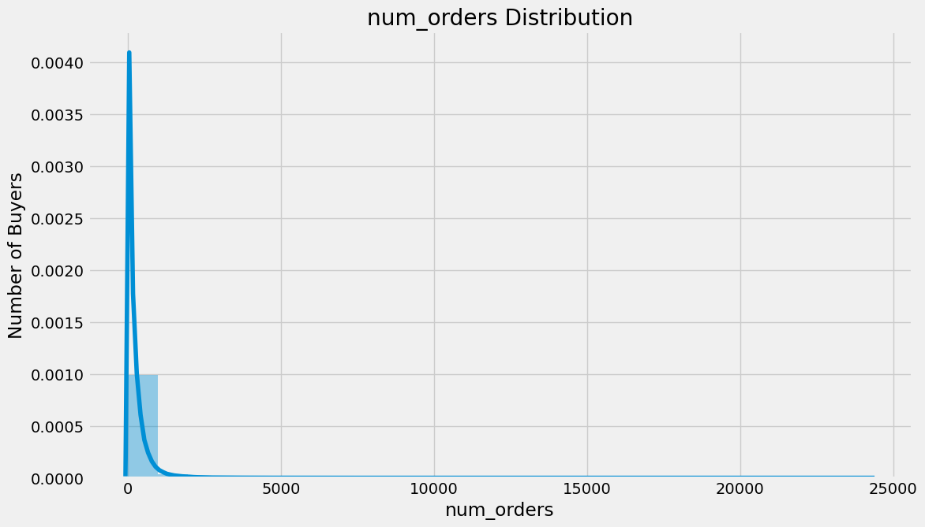

In [37]:

trainfinal2 **=** trainfinal**.**drop(['id'], axis**=**1)

correlation **=** trainfinal2**.**corr(method**=**'pearson')

columns **=** correlation**.**nlargest (8, 'num_orders')**.**index

columns

Out[37]:

Index(['num_orders', 'homepage_featured', 'emailer_for_promotion', 'op_area',

'cuisine', 'city_code', 'region_code', 'category'],

dtype='object')

In [39]:

correlation_map **=** np**.**corrcoef(trainfinal2[columns]**.**values**.**T)

sns**.**set(font_scale**=**1.0)

heatmap **=** sns**.**heatmap(correlation_map, cbar**=True**, annot**=True**, square**=True**, fmt**=**'.2f',

yticklabels**=**columns**.**values, xticklabels**=**columns**.**values)

plt**.**show()

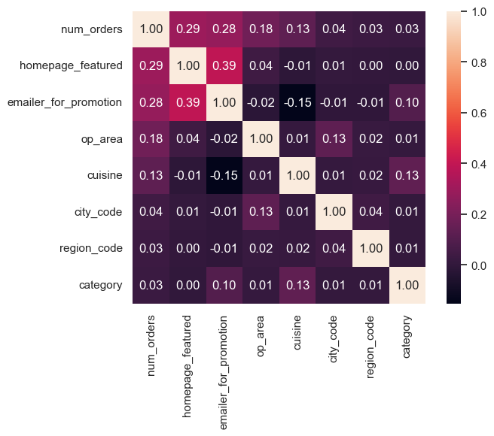

In [41]:

features **=** columns**.**drop(['num_orders'])

trainfinal3 **=** trainfinal[features]

X **=** trainfinal3**.**values

y **=** trainfinal[ 'num_orders']**.**values

In [42]:

trainfinal3**.**head()

Out[42]:

|  | **homepage_featured** | **emailer_for_promotion** | **op_area** | **cuisine** | **city_code** | **region_code** | **category** |
| --- | --- | --- | --- | --- | --- | --- | --- |
| **0** | 0 | 0 | 2.0 | 3 | 647 | 56 | 0 |
| **1** | 0 | 0 | 2.0 | 3 | 647 | 56 | 0 |
| **2** | 0 | 0 | 2.0 | 3 | 647 | 56 | 0 |
| **3** | 0 | 0 | 2.0 | 3 | 647 | 56 | 0 |
| **4** | 0 | 0 | 2.0 | 3 | 647 | 56 | 0 |

In [45]:

**from** sklearn.model_selection **import** train_test_split

In [47]:

X_train, X_val, y_train, y_val **=** train_test_split(X, y, test_size**=**0.25)